How to create an E-Signature in Adobe Acrobat
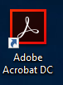

- Open “Adobe Acrobat DC”.
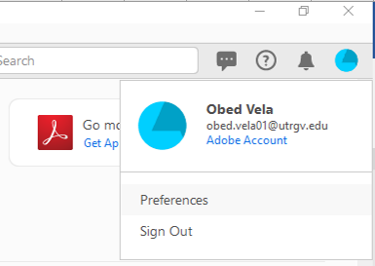

- Once program is open, please click on the
pie chart icon located on the top left
window and then click on the “Preferences”
option.
If you are not signed in Adobe Acrobat then you
will find the “Preferences” option on the top right
menu bar under “Edit”

3rd option – once in adobe press “Ctrl” + “K”

- A new window will pop up.
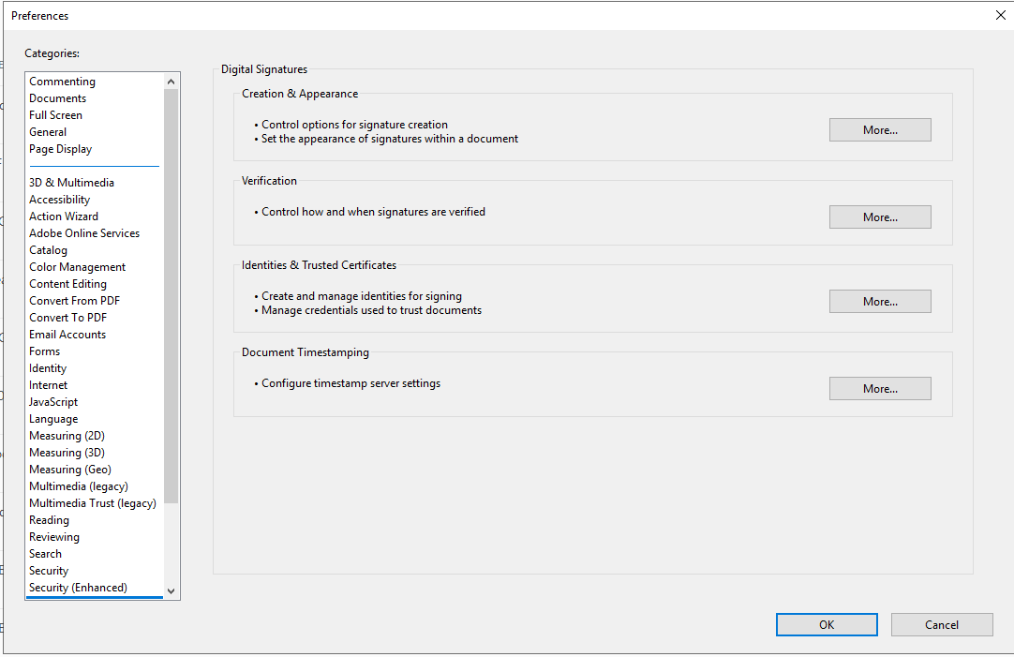

- Scroll down the categories to find “Signatures” then select “More” under “Identities & Trusted Certificates”

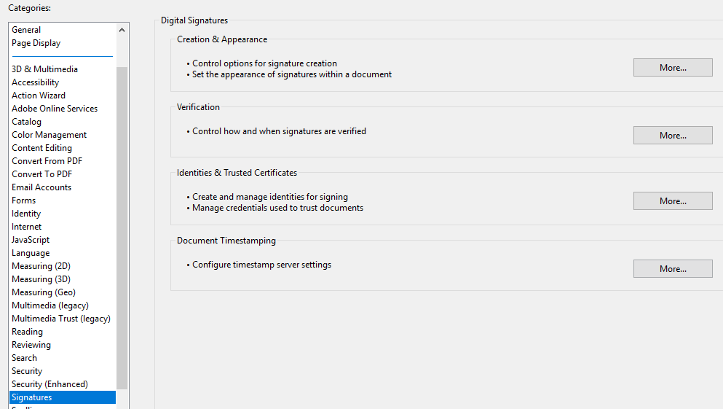
- Select the icon to add your new signature.
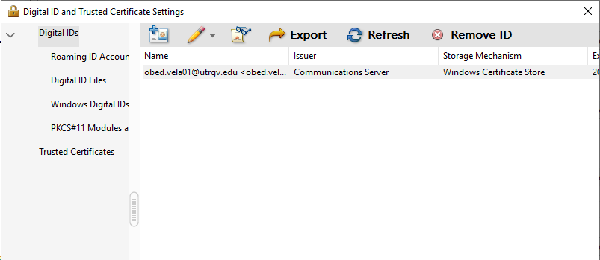

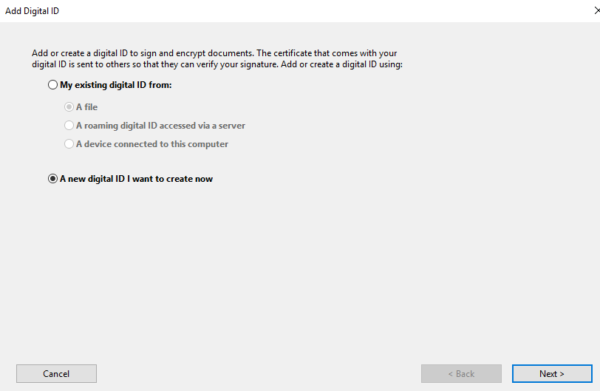
- Select “A new digital ID I want to create now” then click “Next”

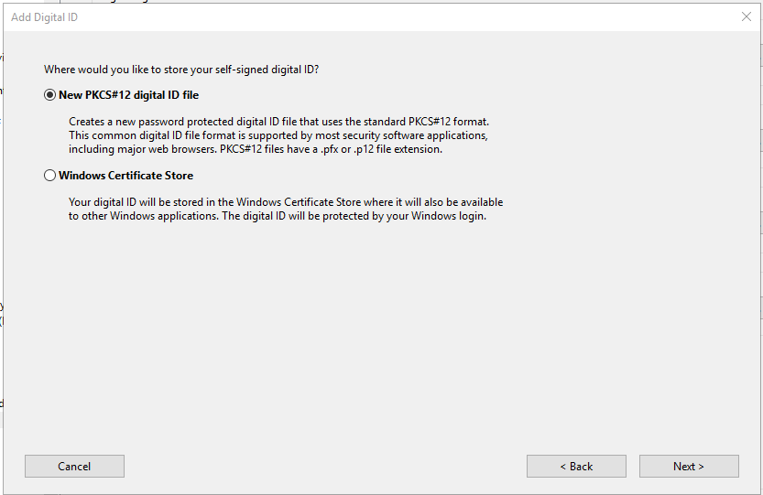
- Select “Next”

- Enter your credentials then click “Next”
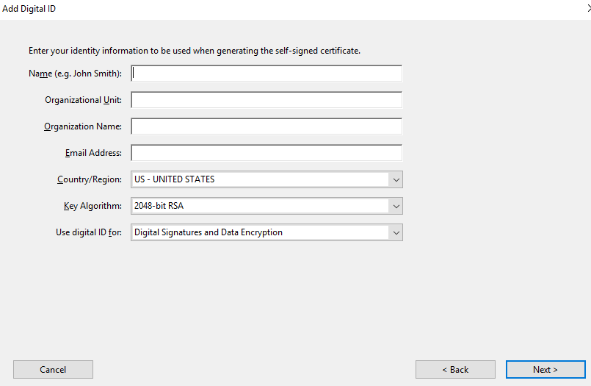

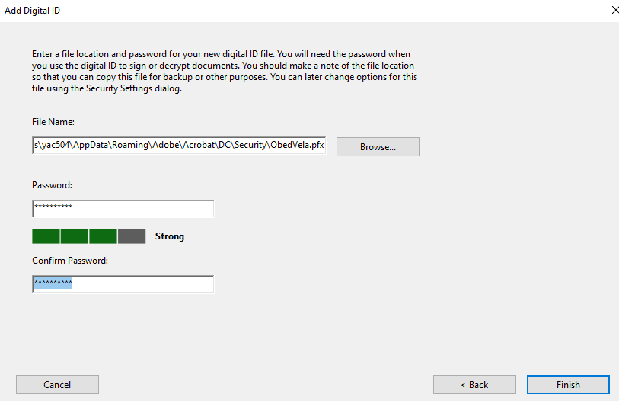
- Please create a password and then select finish.

- You may close all windows and your signature is ready to be use.

