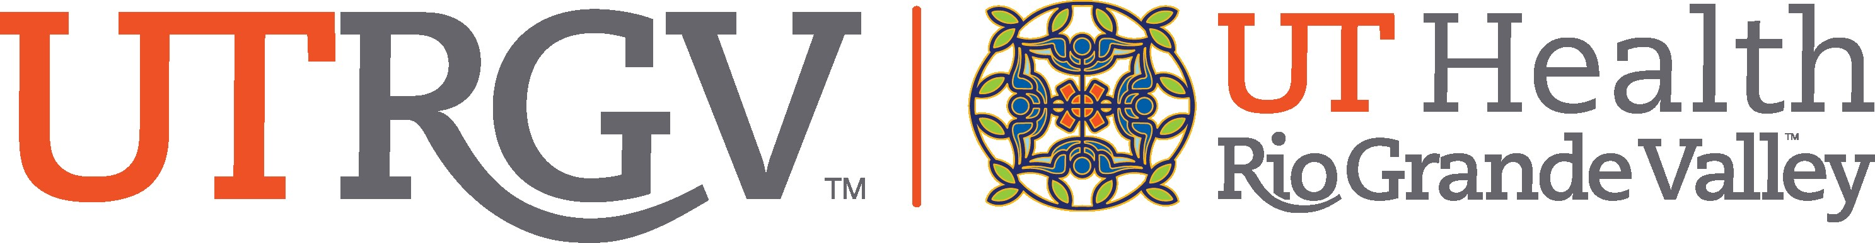

FDA ADMINISTRATIVE ACTION CHECKLIST

Date:
Sponsor Investigator/PI Name: Department:
IND/IDE #: IRB #:

Administrative Action to be taken with the Protocol:
☐Transfer to new institution
☐Transfer to new PI at UTRGV
☐Close Study with IRB

Anticipated date of action noted above:

Please indicate and sign off that the following items have been reviewed by a current UTRGV employee and verified as complete and in compliance:

Regulatory Review: (Print) (Sign and Date)

Monitoring History Review: (Print) (Sign and Date)

Data Analysis/Database Review: (Print) (Sign and Date)

Data Safety Monitoring Board (DSMB) or Independent Safety Monitoring Review (Print) (Sign and Date)

Grants Account/Research Billing Review: (Print) (Sign and Date)

Stock/Supply Review and Reconciliation: (Print) (Sign and Date)
** please note that if any of the items are deemed incomplete or out of compliance, it is the responsibility of the sponsor-investigator to reconcile all items prior to any administrative action taking place.

Have all appropriate parties (listed in SOP GA-106) been notified by the sponsor investigator?
YES NO

Who will be the responsible party within the department to provide oversight for the copying and packing of study related materials?

What courier service is contracted to complete the transfer of documentation to the new institution?

As the sponsor-investigator of the above listed protocol, I acknowledge that the information listed above is accurate and the items identified in the checklist above are current and in compliance with all federal and state requirements:

Print: Sign and Date:

** Please submit this completed form to the Office of Clinical Research for approval, prior to any further administrative action, at clinicalresearch@utrgv.edu.

