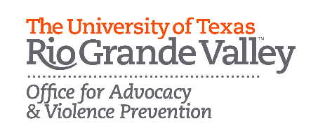
IN AN EMERGENCY, CALL 9-1-1 OR UTRGV Police Department (956) 882-4911
A COLLEGE STUDENT’S GUIDE TO SAFETY PLANNING

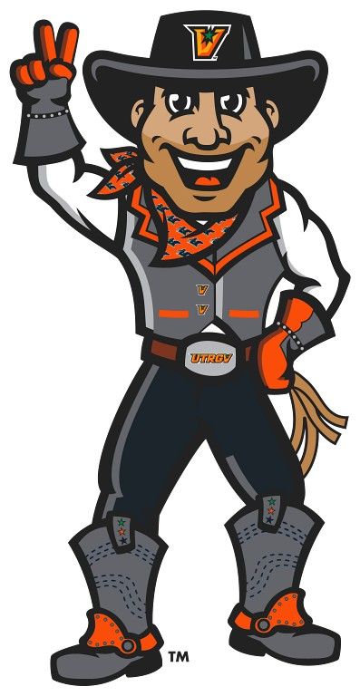
The University of Texas Rio Grande Valley Police Department protects and serves the campus community of students, faculty, staff, and visitors by providing professional law enforcement services and actively promoting community involvement through progressive community policing partnership strategies and a commitment to education.
The Office for Advocacy and Violence Prevention (OAVP) works with students, staff, and faculty, and community partners to strive for a campus free from interpersonal violence and to facilitate services for victims and survivors of sexual assault, domestic violence, dating violence, stalking, sexual harassment, and any type of violence.

ALL SERVICES PROVIDED BY OAVP ARE FREE AND CONFIDENTIAL.
The Office of Title IX & Equal Opportunity (OTIXEO) promotes UTRGV's commitment to providing a learning and work environment free of discrimination, sexual harassment, and retaliation.
WHAT IS A SAFETY PLAN?
SAFETY PLAN
A safety plan is a practical guide that helps lower your risk of being hurt by your abuser. It includes information specific to you and your life that will help keep you safe. A good safety plan helps you think through lifestyle changes that will help keep you as safe as possible on campus, in the campus dorm rooms, at home, and other places you go to on a daily basis.

WHY DO I NEED A SAFETY PLAN?
Everyone deserves a relationship that is healthy, safe, and supportive. If you are in a relationship that is hurting you (physically, emotionally, and/or psychologically), understand that the abuse is not your fault. It is also important for you to start thinking of ways to keep yourself safe from abuse, whether you decide to end the relationship or not. While you cannot control the other person’s abusive behavior, you can take action to keep yourself as safe as possible.

HOW DO I MAKE A SAFETY PLAN?
Take time to develop a safety plan that works for you. You can complete the plan in your own time or work through it with someone you trust, such as an advocate.

KEEP IN MIND

- For this safety plan to work for you, you will need to fill in personalized answers, so you can use the information when you most need it. Some sections may not apply to you but fill out all the ones that do.
- Once you complete your safety plan, keep it in an accessible but secure location. You might also consider giving a copy of your safety plan to someone you trust, such as an advocate.
- Getting support from someone who has experience working with college students in abusive relationships can be very helpful. To connect with an experienced campus advocate, please contact the Office for Advocacy & Violence Prevention (OVAP).

Campus safety is a shared responsibility and there is often no single person who is individually responsible for the effort.
The safest way for me to get to class is: _________
_________________________________________
The possible places on campus where I may run into my abuser are: _________________________
_________________________________________
There are many places on campus where it is impossible to avoid my abuser. If I need to go to one of those places, I can make sure a friend can go with me. I will ask: ________________________
_________________________________________
If I feel threatened or unsafe when I am on campus, I can go to these public places where I feel safe: __
_________________________________________
_________________________________________

STAYING SAFE ON CAMPUS:
I can speak to the following people if I need to rearrange my schedule to avoid my abuser or if I need help staying safe on campus.

Campus Police (EMG): (956) 882-4911
Office for Advocacy and Violence Prevention: (E) (956) 665-8287 (B) (956) 882-8282
Office of Title IX & Equal Opportunity: (E) (956) 665-2453
(B) (956) 882-1905
GUIDE TO SAFETY PLANNING

STAYING SAFE IN MY CAMPUS DORM ROOM OR IN MY HOME:
If I live with or near my abuser, I will have a bag ready with these important items in case I need to leave quickly (check all that apply):
- Cell phone & charger
- Spare money
- Keys
- Driver’s license, student ID or other form of ID
- Copy of my protective order
- Birth certificate, social security card, immigration papers, and/or other important documents

- Books, backpack, computer/laptop, course-related materials, USB/storage devices, or school supplies

- Any school-related financial documents

- Change of clothes
- Medications
- Special photos or valuable items

I can tell these people (roommates, friends, or family) about what is going on in my relationship: ___________
_____________________________________________
_____________________________________________
There will be times when my roommate is gone. If I feel unsafe during those times, I can have people stay with me. I will ask: _________________________________
_____________________________________________
The safest way for me to leave my dorm/home in case of an emergency is: _______________________________
_____________________________________________
If I have to leave my dorm/home in an emergency, I should try to go to a place that is public, safe, and unknown by my abuser. I could go here: _____________
_____________________________________________
I will use a code word so I can alert my family, friends, roommates, and/or RA’s to call for help without my abuser knowing about it. My code word is: _____________________________________________
- No matter where I go, I will be aware of how to leave safely in case of an emergency.

- Wherever I am, I will be aware of my exits.

- I will leave if I feel uncomfortable in a situation, no matter what my friends are doing.

- I will ask my friends to keep their cell phones with them while they are with me in case, we get separated, and I need help.

- I will avoid going out alone.

- I will take alternate routes to school, home, or public places.

- If I plan to drink, I will be sure to have a sober driver who is not my abuser.

- If possible, I will go to different malls, bars, parties, stores, movie theaters, etc. than to ones my abuser goes to or knows about.

- I will spend time with people who make me feel safe, supported, and good about myself.
THESE ARE THINGS I CAN DO TO HELP KEEP MYSELF SAFE IN MY SOCIAL LIFE:
During an emergency, I will call 911 first, and then I can call the following friends, family, or RA life staff at any time of the day or night:
Name: __________________________
Phone#: ________________________

Name: __________________________
Phone#: ________________________

Name: __________________________
Phone#: ________________________

GUIDE TO SAFETY PLANNING
- I will set all my online profiles to be as private as they can be.
- I will save and keep track of any abusive, threatening, or harassing comments, posts, or texts.
- I will never give my passwords to anyone. If the abuse and harassment does not stop, I will change my usernames, email addresses, and/or cell phone number.
- I will not answer calls from unknown, blocked, or private numbers.
- If necessary, I can see if the phone company can block my abuser’s phone number from calling my cell phone.
- I will not communicate with my abuser using any type of technology.
THESE ARE THINGS I CAN DO TO STAY SAFE ONLINE AND WITH MY CELL PHONE:
If I feel confused, depressed, or scared, I can call the following friends, family members, or supportive services:
Counseling Center:
(E) (956) 665-2574 (B) (956) 882-3897
Office for Advocacy and Violence Prevention: (E) (956) 665-8287 (B) (956) 882-8282
Vaqueros Crisis Line: (956) 665-5555
Crisis Text Line: TEXT “HOME” 741741
Name: __________________________
Phone#: ________________________
Name: __________________________
Phone#: ________________________
Name: __________________________
Phone#: ________________________
THESE ARE THINGS I CAN DO TO HELP KEEP MYSELF SAFE EVERYDAY:
- I will always carry my fully charged cell phone and important telephone numbers.

- I will keep in touch with someone I trust about where I am or what I am doing.

- I will call 911 if I feel my safety is at risk.

- I will avoid places where my abuser or their friends and family are likely to be.

- If I live in the dorms, I will alert campus police, OAVP, Title IX, or residence life about what is happening in my relationship so that my abuser is not allowed in my building.

- I will keep the doors and windows locked where I live, especially if I am home alone. I will make sure my car doors are always locked.

- I will avoid speaking to my abuser. If it is unavoidable, I will make sure there are people around in case the situation becomes dangerous.

- I can look into getting a protective order so that I can have legal support in keeping my abuser away.

- I will request a safe escort to a building or my vehicle available to me anytime via campus police.

- I will remember that the abuse is not my fault and that I deserve a safe and healthy relationship.
My abuser often makes me feel bad by saying or doing this: ___________________________
_____________________________________
When they do this, I will think of these reasons why I know my abuser is wrong: ___________
_____________________________________
I will do things I enjoy such as: _____________
_____________________________________
I will join clubs or organizations that interest me such as: ______________________________
_____________________________________
STAYING SAFE EMOTIONALLY:
GETTING HELP ON OUR CAMPUS:
Office for Advocacy and Violence Prevention: (E) (956) 665-8287 (B) (956) 882-8282
Counseling Center: (E) (956) 665-2574 (B) (956) 882-3897
Office of Title IX & Equal Opportunity: (E) (956) 665-2453 (B) (956) 882-1905
Campus Police (EMG): (956) 882-4911
Student Health Services: (E) (956) 665-2511 (B) (956) 882-3896
Dean of Students: (956) 665-2260 (B) (956) 882-5141
Student Rights and Responsibilities: (956) 665-5375
GETTING HELP IN YOUR COMMUNITY:
For emergencies: 911

National Dating Abuse Hotline: 1-866-331-9474
National Domestic Violence Hotline: 1-800-799-7233
TEXT “start” to 88788
National Sexual Abuse Hotline: 1-800-656-4673
National Alliance on Mental Illness (NAMI): 1-800-950-6264
TEXT “Helpline” to 62640
Substance Abuse and Mental Health Services Administration (SAMHSA): 1-800-662-4357
Suicide & Crisis Lifeline:
988

Family Crisis Center: 956-423-9305
Friendship of Women: 956-544-7412
Mujeres Unidas: 956-630-4878
Cameron County District Attorney’s Office: 956-544-0849
Hidalgo County District Attorney’s Office: 956-292-7600

Crisis Text Line: TEXT “HOME” 741741
GUIDE TO SAFETY PLANNING

